**ASSIGNMENT**

* First reverse
* First Factorial
* Longest word
* Bracket Matcher
* UpperCase

**REVERSE:**

**PSEUDOCODE**

* 1. The split() method splits a string object into an array of string by separating the string into substrings.
  2. The reverse() method reverses an array In place.
  3. The first array element becomes the last and the last becomes the first.
  4. The join(“ “)method joins all element of an array into a string.

**FLOWCHART**

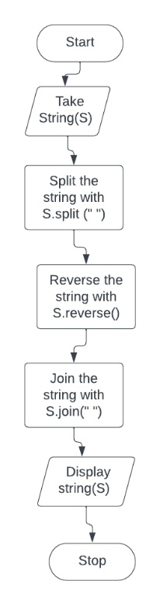

**2.FACTORIAL**

**PESUDOCODE**

1. Declare N and F as integer variable
2. Initialize F=1
3. Enter the value of N
4. If yes then, FACT=FACT*N
5. Enter the value of N by 1
6. Repeat step d and e until N=0[K
7. Now print the value of F

Longest Word

**3.PSEUDOCODE**

1. Sentence .split return an array of words.
2. Since the previous steps creates as we can reduce on it.
3. Reduce take two arguments: the “accumulator and the current element(current word)”.
4. In each iteration of the callback, we return the longer of the words.
5. Reduce initially start with empty string to guarantee that there’s always something longer.

**4.BRACKET MATCHER**

**PSEUODOCODE**

1. Input are strings of () and [],
2. Output are yes/no, so that if bracket matches and matches with the same type.
3. Prove your running time with big o notation
4. **PSEUDOCODE**
5. It take an input string from the user (assuming It Is lowercase).
6. Convert it to uppercase

**FLOWCHART**

